Type or paste the title of the work here

**by**  
**[Firstname Lastname]**

[Previous degree, institution, YEAR]  
[Previous degree, institution, YEAR – if more than one list in descending order]

[Thesis/Project/Extended Essays] Submitted in Partial Fulfillment of the  
Requirements for the Degree of  
[Master of…/Doctor of…]

in the  
[School/Department of …]  
[Faculty of …]

© [Firstname Lastname] YEAR  
SIMON FRASER UNIVERSITY  
[Term YEAR]

Copyright in this work rests with the author. Please ensure that any reproduction   
or re-use is done in accordance with the relevant national copyright legislation.

Declaration of Committee

|  |  |  |
| --- | --- | --- |
| **Name:** | **[Firstname Lastname]** | |
| **Degree:** | **[Master of …/Doctor of …]** | |
| **Thesis title:** | **Type or paste the title of the work here** | |
| **Committee:** | **Chair:** | [Firstname Lastname] [Academic Role, Academic Unit] |
|  | **[Firstname Lastname]** Supervisor [Academic Role, Academic Unit] | |
|  | **[Firstname Lastname]** Committee Member [Academic Role, Academic Unit] | |
|  | **[Firstname Lastname]** Committee Member [Academic Role, Academic Unit] | |
|  | **[Firstname Lastname]** Committee Member [Academic Role, Academic Unit] | |
|  | **[Firstname Lastname]** Committee Member [Academic Role, Academic Unit] | |
|  | **[Firstname Lastname]** Examiner [Academic Role, Academic Unit] | |
|  | **[Firstname Lastname]** External Examiner  [Academic or Professional Role, Academic Unit] [Institution] | |

Please review the Declaration of Committee page instructions on the library’s thesis website before completing this page:   
[**https://www.lib.sfu.ca/help/publish/thesis/format/declaration-committee**](https://www.lib.sfu.ca/help/publish/thesis/format/declaration-committee)

Remember to delete this note before submission.

Ethics Statement

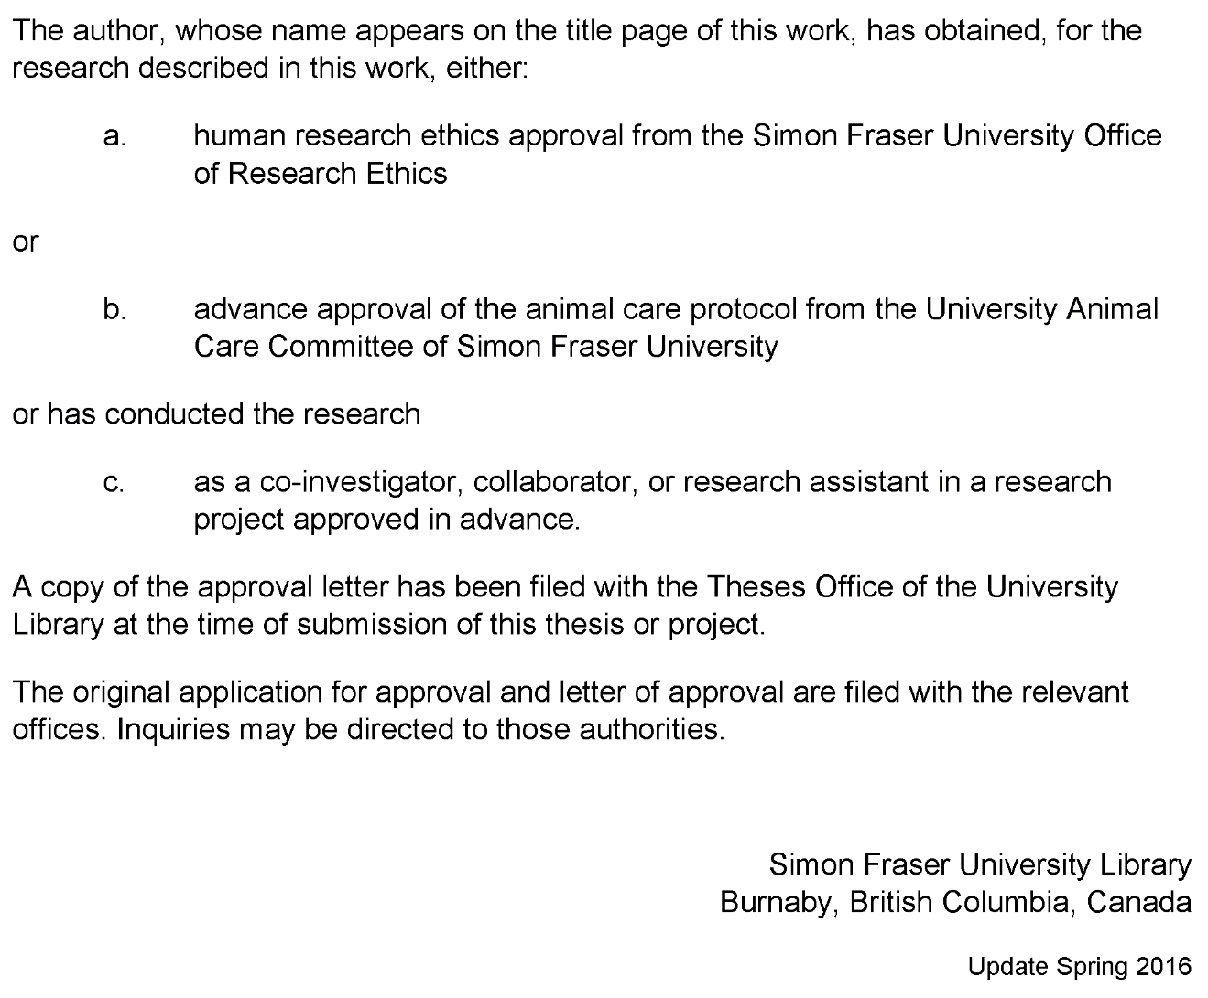

This page must appear as p. iii if your research required ethics approval. Remember to delete this note before submission.

If an ethics exemption was granted, this page must be removed.

If ethics approval was not required, this page must be removed.

Remember to update the Table of Contents after removing this page.

Abstract

Fishery data visualization plays important role for companies in countries with developed fishery infrastructure

In my paper I am going to show trends, anomalies, year-by-year comparison (drill-down) of fishing catches and money value.

Showing correlation between these two parameters for each Canada province and fish species is a main part of the work.

This will provide a user-friendly way to show all necessary data for non-domain expert users in a web browser, using the novel js library amCharts.

Tool will help users to see/identify issues with fish amounts in certain regions as well as help fishery managers to add or remove restrictions on fish quotas etc. The tool can help to answer questions like “Which species is being caught and how much of it?” or “Is the biological diversity of the fishery threatened?”

Having it in a web browser is very handy for users because they don’t have to install software on their computers which may not be compatible with OS.  
This will be a highly accessible multi platform tool which will help to analyze table data much quicker and will give some answers for users who are interested in the fishery domain.

**Keywords**: fishery; web-interface; visualization; online platform

Dedication

This is an optional page. Use your choice of paragraph style for text on this page (**1_Para_FlushLeft** shown here).

To hide the heading at the top of this page, select the text and change the text colour to white.

Acknowledgements

This is an optional page. Use your choice of paragraph style for text on this page (**1_Para** shown here).

Table of Contents

Declaration of Committee ii

Ethics Statement iii

Abstract iv

Dedication v

Acknowledgements vi

Table of Contents vii

List of Tables ix

List of Figures x

List of Acronyms xi

Glossary xii

Preface/Executive Summary/Image xiii

Chapter 1. Introduction 1

Chapter 2. Related Work 2

2.1. Role of the Fishery Visualization 2

2.2. Marine Environmental Management 2

2.3. Approaches to Visualization 5

Chapter 3. Design and Use Cases 6

3.1. Importance of Fishery Visualization 6

3.2. Fishery Domain Problems 12

3.3. Data Sources and Data Proccessing 13

3.4. Visualization Motivation 15

3.5. Problem Set 15

Problem 1 Exploring Relationships between Fish Amounts and Price 15

3.5.1. 15

3.5.2. Problem 2 Paired Time Series (Fish Amount and Price) 16

3.5.3. Problem 3 17

Identifying Top Fish Species by Catch Amount or Price Value 17

3.5.4. Problem 4 17

Consequent Years Fishery Data Comparison 17

Chapter 4. Implementation and Evaluation 19

4.1. Overview of the Tool’s User Interface 19

4.2. Visualizations Overview 20

4.2.1. Problem 1 20

4.2.2. Problem 2 20

4.2.3. Problem 3 21

4.2.4. Problem 4 22

Chapter 5. Conclusions and Future Work 24

Chapter 6. Bibliography 25

New References (not used yet) 27

Appendix A. An Example of an Appendix 29

**Error! Hyperlink reference not valid.Error! Hyperlink reference not valid.Error! Hyperlink reference not valid.Error! Hyperlink reference not valid.Error! Hyperlink reference not valid.Error! Hyperlink reference not valid.Error! Hyperlink reference not valid.Error! Hyperlink reference not valid.Error! Hyperlink reference not valid.Error! Hyperlink reference not valid.Error! Hyperlink reference not valid.**Error! Hyperlink reference not valid.Error! Hyperlink reference not valid.**Error! Hyperlink reference not valid.Error! Hyperlink reference not valid.Error! Hyperlink reference not valid.**Error! Hyperlink reference not valid.**Error! Hyperlink reference not valid.Error! Hyperlink reference not valid.Error! Hyperlink reference not valid.Error! Hyperlink reference not valid.Error! Hyperlink reference not valid.**Error! Hyperlink reference not valid.Error! Hyperlink reference not valid.Error! Hyperlink reference not valid.Error! Hyperlink reference not valid.Error! Hyperlink reference not valid.

List of Tables

**No table of figures entries found.**

Use References>Insert Caption to create caption labels and numbers. Right-click on the text above and select Update Field to update this list. See the Thesis Template Instructions for information on creating tables, figures, and captions.

Remember to delete this note before submission.

If there are no tables in the document, remove this page.

List of Figures

**No table of figures entries found.**

Use References>Insert Caption to create caption labels and numbers. Right-click on the text above and select Update Field to update this list. See the Thesis Template Instructions for information on creating tables, figures, and captions.

Remember to delete this note before submission.

If there are no figures in the document, remove this page.

List of Acronyms

|  |  |
| --- | --- |
| SFU | Simon Fraser University |
| LAC | Library and Archives Canada |
|  | This is an optional page and can be removed if not used. |
|  | Use one table row for each item to allow sorting using Word’s table tools. |
|  | Apply the style **1_Para_NoSpace** to table rows as shown here. |
|  |  |
|  |  |

Glossary

|  |  |
| --- | --- |
| Thesis | An extended research paper that is part of the final exam process for a graduate degree. The document may also be classified as a project or collection of extended essays. |
| Glossary | An alphabetical list of key terms |
|  | This is an optional page and can be removed if not used. |
|  | Use one table row for each item to allow sorting using Word’s table tools. |
|  | Apply the style **1_Para_NoSpace** to table rows as shown here. |
|  |  |

Preface/Executive Summary/Image

This page can be used for a Preface, Executive Summary, or introductory image. This is an optional page and can be deleted if not used.

To hide the heading at the top of this page – e.g., if using an introductory image – select the text and change the text colour to white.

Do not delete the section break that follows this paragraph. If the section break is not visible, turn on non-printing characters using the Show/Hide icon (¶) on the Home ribbon.

# Introduction

Main motivation for my research is to help users to make their work faster and more productive. I’m working on a software development company right now and sometimes we have requests not only for giving access to raw table data but for data processing, analysis and making some reports.

Of course, digging into raw data might give you results that you expect, but it usually takes a lot of time if you have a big amount of data or are not very familiar with computer software.

Visual data representation plays a very important role in data analysis. It can condense huge amounts of data into several plots and labels, giving you information about trends, it is easier to compare pictures than data rows for sure.

My research will help people who are domain experts but not very familiar with data analysis tools. The tool can help fishery management with regulation of fishery catching in certain Canadian provinces, and will help to decide which policies or fishing quotas for specific fish types should be applied.

# Related Work

## Role of the Fishery Visualization

Visualization is a very important tool for decision support in fisheries information systems. It can give a person, who is working with fishery information more insights about data. It usually saves time for making correct decisions about business logic of the fishing company, because it is easier to see trends, outliers etc. while using charts and interactive diagrams rather than just looking through a spreadsheet, which may be located even in different files.

There are different groups of users in the fishery domain. Papers, discussed in this chapter are oriented mostly for fishery management, but written in a way that it is not easy to understand completely if you are not a data analyst or/and experienced computer user.

Main goal of the work is to create a tool which will be easily accessible for both types of users: data scientists and fishery management which are making decisions based on conclusions of the data presented in a tool.

## Marine Environmental Management

FishCAM2000 (FC) [1] is a computer-based integrated information system for fisheries management and marine environmental monitoring. It illustrates a visualization of the fishery activity over the same spatial area of interest for a special type of fish etc. It has a simple and user friendly interface implemented in Windows Forms. Figure 2.1.1 below shows output after user passes 7 screens of settings of the query wizard. It looks like there are too many steps for a user to get a result, but it was a requirement for the tool to be as generic as possible. Good point is that it presents complex geo data on the map instead of the data table which is a huge time saving for users to understand the query output.



Figure 2.1.1

Next work which is to mention is a tool which gets and analyzes data which is directly coming from vessels [2]. It is also geographical data and the amount of fish caught by a particular vessel in a certain region. Authors show not only geographical spread of fish, but they also have year-to-year comparison charts (Figure 2.2.2).

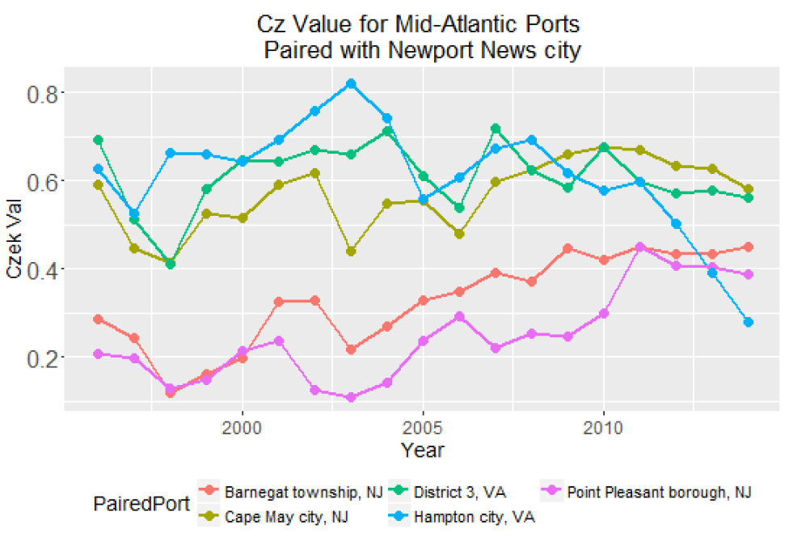

Figure 2.2.2

Whereas the works we have discussed so far focussed on the visualization of geographical and vessel related data, the work of da Silva, Charles Fulcher [3] allows the investigation of land-sea connections. It shows to the reader human impact on the sea from land and vice versa. The maps show the connection between vessels and ports and also depict the distribution of gear types used in different regions etc. All that is done with descriptive labels, lines and appropriate legends which any person can be easily understood.

The work of Barrus about the state of the salmon [4] provides a good basis for a platform to support analysis and interaction for fishery data through visualization. It uses DFO data related to salmon in BC rivers and the author discussed and tried to produce visualizations for questions that marine experts asked him to solve. In particular, in his work he says that all data sources for DFO are decentralized and there is practically no interface which allows user to analyze data. So he combined several data sources and produced visualizations which answers questions about the state of salmon in Canadian rivers.

## Approaches to Visualization

The paper with time series prediction on stocks [5] mostly shows the difference between prediction algorithms, but the visualization part requires special attention. Authors used distinct color coding to show results, there is no extra information on the chart which distracts or confuses readers.

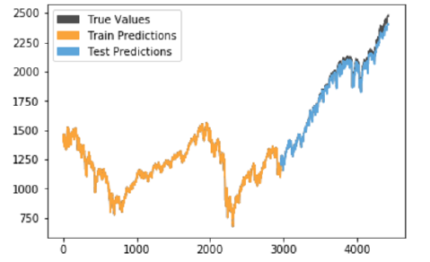

Figure 2.3.1

IDMVis [6]: a visualization tool for a patient with diabetes which shows multidimensional interrelated data during the day. IDMVis includes a novel technique for folding and aligning records by dual sentinel events and scaling the intermediate timeline. It was designed to help doctors to track the state of important parameters of patients and to detect anomalies. After that it can be used as a decision support tool for treatment of diabetes. Design decisions were evaluated by six clinicians.

Papers discussed in this subsection are mostly explaining one visualization technique, but Sofia Semikina in her thesis work Stress Data Visualization [7] compares methods of visualizing the same data in various amount of charts and diagrams of different types. She uses bar charts, line charts, pie charts, spiral charts. There is also user study involved in her work which shows in the end which visualization particular users understand better.

# Design and Use Cases

## Importance of Fishery Visualization

Ability to see yearly correlation is an important question for marine scientists, biologists and businesses which relay on a specific fish type.

According to the articles and papers below people are more and more concerned about the state of the fish in the world ocean.

**Fish population monitoring** [8]

Reporting on the status of aquatic resources and how they are changing over time and understanding the impacts of large scale disturbance and human activities on aquatic resources are among the most important processes for assessing the state of ecosystems.

To display the human influence on an ecosystem or a certain type of fish, data on the amount of catch of this species by region, the number of the species in comparison with previous years, data from the SARA and COSEWIC organization about species at risk etc. can be useful.

The 1993 Report on the status of groundfish stocks in the Canadian Northwest Atlantic [9] reported cod catch data. Used multiplicative analyzes of catch-at-age from research surveys and the commercial fishery and on average fishing mortalities from preliminary SPA. Based on these data, it was concluded that fishing mortality (page 17) and that there has been a gradual decline in stock size through the second half of the 1980s.

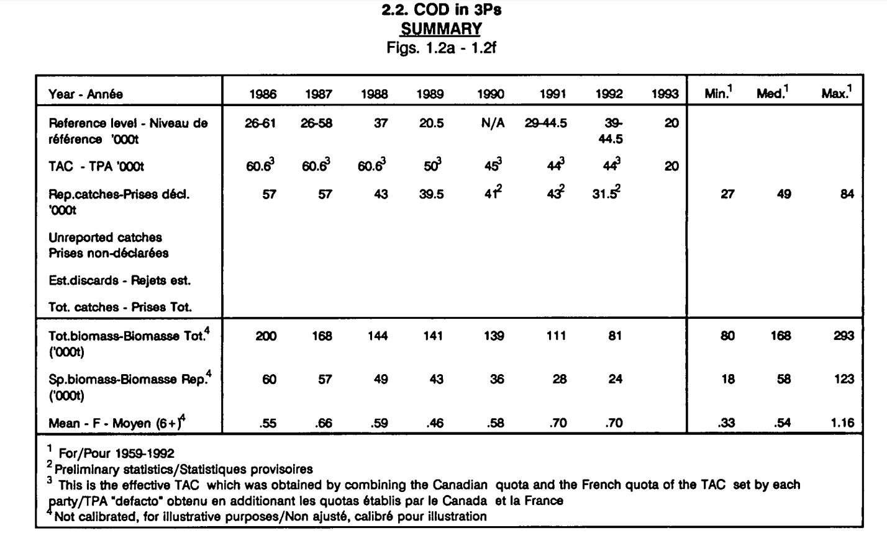

Figure 3.1.1

In the same report, data on the amount of COD catches from 1960 to 1994 was provided and compared with data on the population of different age groups of this species, fish mortality, recruitment, supply and demand, etc. for the same period of time.

The Stock Status Report [10] for 2004 year provided abundance data for Northern Abalone for each year (see Figure 3.1.2). This figure shows that since 1998 the abundance of this species has fallen below the permissible short-term recovery objective line.

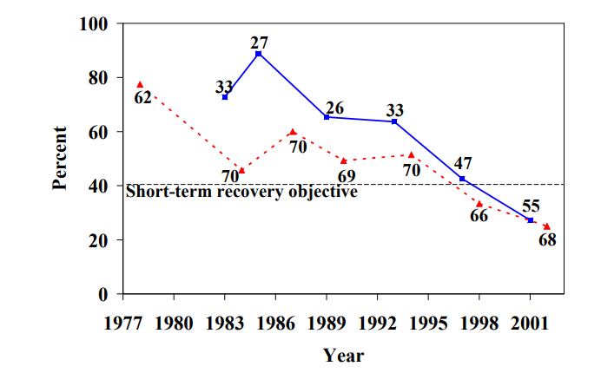

Figure 3.1.2

More recent annual environmental reports also show this kind of data. For example, Scottish Sea Fisheries Statistics [11] for 2019 from the Cabinet Secretary for Rural Economy and Tourism provides both summary data and more detailed statistics by region. From the information related to this topic, the following can be distinguished:

* Total amount of caught fish (tonnage) and profit

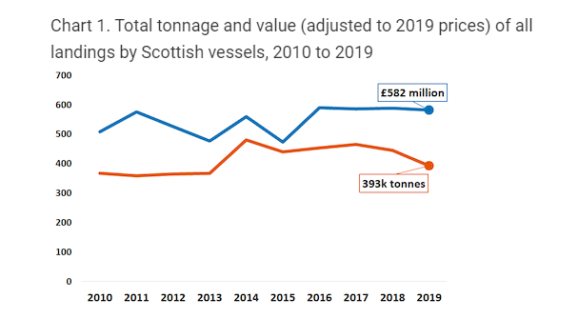

* Percentage of Scottish vessels’ landings by species type in 2019

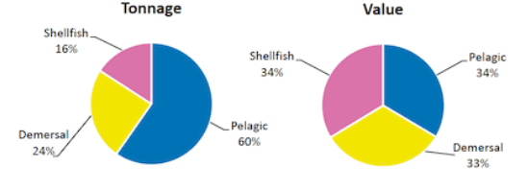

* Change in total tonnage and value of landings by Scottish vessels between 2018 and 2019

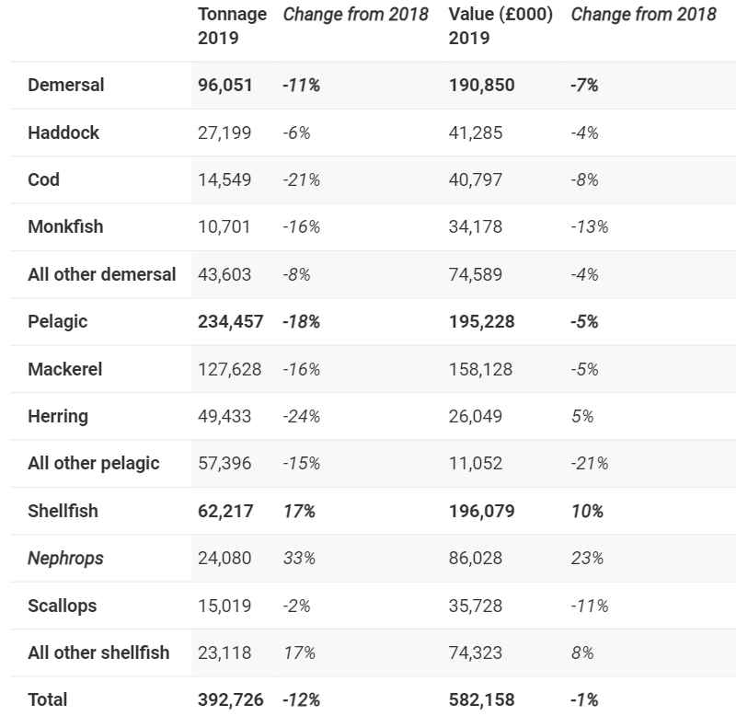

* Tonnage of landings by Scottish vessels by species type 2010 to 2019

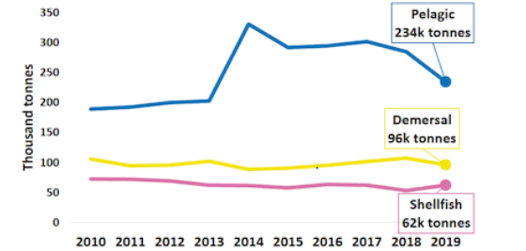

* Real terms value of landings by Scottish vessels by species type 2010 to 2019

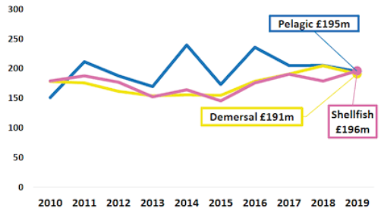

* Trend in tonnage of key species (value of £20 million or over) landed by Scottish vessels 2010 to 2019

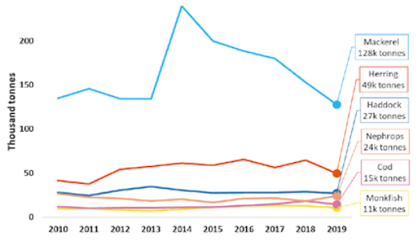

* Trend in real value of key species (value of £20 million or over) landed by Scottish vessels 2010 to 2019

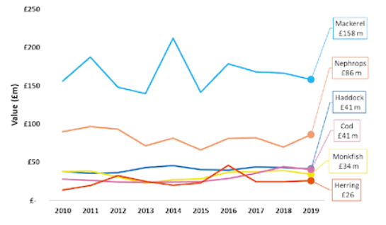

* Real terms price per tonne for key species (value of £20 million or over landed by Scottish vessels) 2018 and 2019

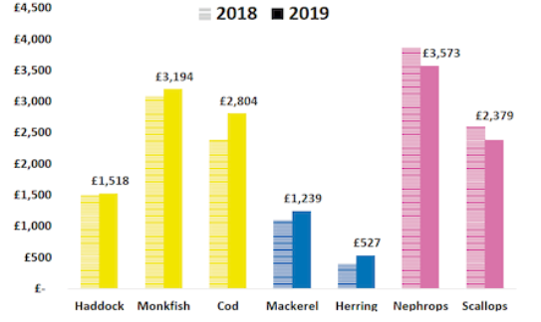

* Percentage quota uptakes of key commercial stocks by vessels in Scottish Producer Organisations in 2019

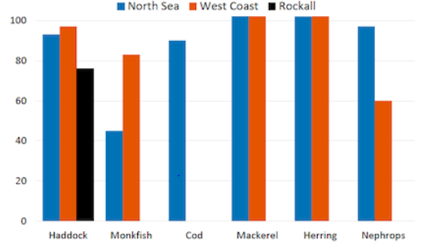

This report is a good example of data visualization to assess both the environmental and economic side of a problem.

The reports described above were made in different periods of time, however, you can see that the data provided is very similar and differ only in the way they are visualized. From this we can conclude that these data visualizations are and will remain relevant for a long time.

List of the disadvantages that unite all the works examined above:

- Some data is provided only in tables, which greatly sophisticates the ability to visually evaluate the information.

- Some captions are missing on the charts, which also complicates the perception of the displayed information.

- All visualizations are presented as static images, to use interactions involved.

3.2. Fishery Domain Problems

It’s also worth mentioning problems on which marine scientist are eager to work on.

Ecological:

1) determining the optimal amount of catch for each type of fish to reduce environmental damage in a particular region

2) understanding how the fish catch affects the ecosystem and other species

3) seeing what species of fish and other animals are on the edge of extinction

4) identifying the regions that primarily need attention and the introduction of measures to restore or prevent the disappearance of the species or ecosystem changes

5) predicting which species may also be subject to negative or positive effects (trends)

6) establishing quotas (permissible amount of fish landing), which will minimize the negative effect on the environment

7) determining the rate of ecosystem restoration after the introduction of appropriate measures

8) analyzing the safety of methods for catching a certain type of fish in each region

9) according to the results of the analysis, stop methods that have negative effects on the state of the environment and/or suggest alternative methods

**Discussion of ecological factors**

In a 2008 publication of Bedford Institute of Oceanography [12], which described many factors affecting different ecosystems, aquaculture research, various data collection methods and technologies, the authors mentioned Recovery Objectives for North Atlantic Right Whales, among which the following issues were described:

- reduction of death and injury from vessel strikes

- reduction of death and injury from fishing gear entanglement

- reduction of injury and disturbance from vessel noise, exposure to contaminants, and other forms of habitat degradation

- monitoring populations and threats

Based on these data, it can be concluded that the environment is adversely affected by the raising amount of fishing vessels and equipment for fishing in the ocean.

The Federal Register - The Daily Journal of the United States Government [12] provides data on Marine Mammal Species and Stocks Incidentally Killed or Injured during the 2018 fishing catch.

By obtaining the average annual data on the number of accidentally killed or damaged fish during the catch for Canada and comparing it with the data about the number of fish caught in the same year, it is possible to estimate the environmental damage during the catch. Depending on the amount and detail of the data, it is possible to estimate the damage for a specific type of fish and / or for each region. Also, fish species can be combined into groups according to their catching methods and ecological influence can be analyzed for each group.

Economical:

1) analyzing supply and demand, then, establishing the optimal amount of fish catch

2) identifying factors affecting demand

3) comparing alternative methods for benefits and profits (fish farms etc.)

## Data Sources and Data Proccessing

Data source for the visualization is taken from DFO Canada website for provincial seafisheries.

Format: Data tables provide the volume and value of seafisheries landings. Data is organized by species-groups, by main species and by province.

Period covered: Data is available from 1990 to 2018 year before the current fishing season, data prior to 1990 is available upon request.

Sources: Data collected by DFO regional offices.

Data is separated yearly (one Microsoft Excel file for each year) and grouped inside by Canadian provinces for each fish type. In total this dataset consists of 56 files (28 for fish amount in tonnes and 28 for fish total value in thousand of Canadian dollars.

To present such kind of data, it should go through several processes which includes data extraction, cleaning/filtering and massaging (converting into suitable format).

1. Data extraction

Data extraction step is basically downloading Excel files from DFO official website. It doesn’t require any extra permissions, data is publically available. However, process of downloading is manual, can be improved if DFO could provide API to use for getting up-to-date data if necessary.

1. Data cleaning

Excel files contains some information, which is not relevant for visualization (for ex. table borders, text color, other meta data, etc.) So it is removed at this step.

1. Data converting

The last step of data processing is converting Excel file to CSV (as intermediate step) and then jonverting it into JSON file which can be easily interpreted by visualization library and any modern browser.

## Visualization Motivation

Analysis of the data presented in table or text format may take significant amount of time. For example, it is hard to see trends, how values change through the years, as well as comparing data for different provinces and fish type. Another thing which is hard to capture is correlation between price and quantities of a specific types of fish for a certain period.

The tool itself and it’s implementation will be discussed in Chapter 4, however, it is worth mentioning that it is developed for people who may not be data scientists. The main goal is to make it usable for people with average knowledge about computers. It also will not require any installation steps, because it is a web application which can be accessible just by typing url in any of the modern browsers. Another feature of the tool is that it will allow user to select range, provinces and any fish type from dropdowns, zoom into details etc. This type of UI experience if not available if it is done through Excel charts or Python library PyPlot. Visualizations in these cases are static and should be re-rendered if some parameters of visualization are changed. Also it requires advanced knowledge of Microsoft Excel or programming.

## Problem Set

### Problem 1 Exploring Relationships between Fish Amounts and Price

Scottish report [11] shows that charts for the fish amounts and price are relevant for people who work in marine industry. This work contains decent amount of plots for fish amount and prices separately on differen figures. They also have different visualizations for the prices and tonnage of the fish of specific type.

Improvement of that report would be placing them on one line chart with two axes to help user see both amount at the same time. This helps to understand correlation between the values and quantities without a need for looking into two different charts (they may be in different scale etc.) or comparing row table data.

Visualization (combined with external data sources and/or user’s knowledge and experience in the domain) may be used by users for solving range of issues such as listed in chapter 3.1.

### Problem 2 Paired Time Series (Fish Amount and Price)

Visualization of the paired time series play an important role in the marine fishery industry, such as in work retaled to parrotfish population by Valle and Oxenford [14]. In this paper there are scatter-plots showing relationships between human population size and fish density for selected fish groups across the Caribbean (fig. 3.5.2.1).

fig. 3.5.2.1

For DFO data visualization was used similar approach but with different time series (fish amount and quantities). One axis is fish quantity, second is fish price and dots represent years which is a third dimension in that case. Visualization shows user the trend of how these values change over time together. Improvements of the visualization comparing to the paper [14] are that it has more advanced filtering, zooming and used interaction. Details of implementation are discussed in the following chapter 4.

### Problem 3

### Identifying Top Fish Species by Catch Amount or Price Value

Knowing which types of fish give the biggest income is valuable for the fishermen and management. In British reports [11] there are pie charts which briefly describe the data for the year.

Pie charts presented in this thesis are more advanced. This visualization can help to find recordmens and outliars for the selecter year. There is also grouping for fish types which have a small percentage of catch or value compariong to the others which is an improvement (for more than 20 legends pie charts usually look overcrowded and not readable.

### Problem 4

### Consequent Years Fishery Data Comparison

Similarly to the previous section 3.5.3, there is a visualization for two consequtive years DFO data.

The main point for this kind of visualization is to show fishery management and policy makers trend for the quantities and fish price.

Policy makers and environment workers or biologists are mostly interested in seeing fish quantities trend to determine if the decisions made in previous year lead do the desired results in the current (such as establishing fishing quotas, studying how some kinds of pollutions affect fishing population).

Howewer, fishery management are more looking into fish price to decide which kind of fish has more sense to aim for catching for the following year.

This chart also helps enfironmentalists and fishery management to communicate with each other. In a way that based on these values fishery management requests which type and how much fish are they planning to catch. And policy makers based on the same plot and internal data and knowledge approve or deny a request.

Chart itself in an improvement of the bar charts, called categorized bar chart. This visualization will show price and fish amounts for the selected two consequtive years based on province and grouped by fish type.

# Implementation and Evaluation

The datasource comes from DFO (Fisheries and Oceans Canada). It is about fishing amount catches and money profit for years from 1990 until 2018.

I am creating a visualization tool to help people to understand / analyze table data in a more suitable format as chats, comparison diagrams etc.

The tool itself is implemented in typescript (wrapper for JavaScript) from Microsoft. Frontend framework is angular 10 which is one of the most powerful and highly used web engines in the world. Back end is not needed for now as it is a test project. If the data source is changed there will be minimum code modifications to get / process data.

The main reason for choosing a web solution for implementing visualization is that it will be accessible for users without a need of installation any additional software.

Having everything in a web browser is a modern way of viewing and sharing visualizations. User doesn’t have to do any extra manipulations with computer system in order to access visualizations.

## Overview of the Tool’s User Interface

On the top of the page there are controls which are used for interacting with data, which comes from DFO and converted into JSON fromat.

Date range slider allows user to select particular years of interest which user would like to study and create visualizations for.

There are two multiple selection pickers for provinces and fish types which are also filtering data.

Based on the user input there may be 4 different visualizations generated.

## Visualizations Overview

### Problem 1

If the date range selected is more than 2 years, there will be visualization generated as on the figure below.

(sample screenshot)

This visualization will help user to figure out relationships between fish quantities and prices for the particular provinces and / or fish type.

is

### Problem 2

Second chart is a scatter plot on which x axes is price and y axes is quantities of particular fish types and province (picture is below). Bullet points and labels represent years.

This visualization helps users to clearly see correlation between price and quantities throughout the selected years.

### Problem 3

If only two years are selected, bar chart report as in “British Reports” will be created. This kind of data presentation is particularly useful for determining trends for the current and previous year. For fishery management it is important to know if, for ex. New policies and laws or fishing quotas are working into intended direction.

### Problem 4

If the user selection is only one year, then pie charts for fishing quantities and prices for province will be created.

The main feature of the chart is that it catches of some fish types are smaller that particular threshold, it will be grouped into “Other” category. This solves a well known problem with having too many unnessessary labels (legends). But on click on the “Other” category user can drill down to see more details for the fish types which are the “outliers” in the dataset.

# Conclusions and Future Work

Bringing different datasources

Chapter 6. Bibliography

|  |  |
| --- | --- |
| [1] | Z. Kemp and G. Meaden, "Visualization for Fisheries Management from a Spatiotemporal Perspective," 2002. |
| [2] | Sharon Benjamin, Min-Yang Lee, Geret DePiper, "Visualizing Fishing Data as Rasters," 2018. |
| [3] | Patricia Pinto da Silva, Charles Fulcher, "Using GIS to Visualize Land/Sea Connections: Case Study - NE Herring Fishery," 2007. |
| [4] | M. Barrus, "The State of the Salmon," 2017. |
| [5] | Aaron Elliot, Cheng Hua Hsu, "Time Series Prediction: Predicting Stock Price," 2017. |
| [6] | Yixuan Zhang, Kartik Chanana, Cody Dunne, "IDMVis: Temporal Event Sequence Visualization for Type 1 Diabetes Treatment Decision Support," 2018. |
| [7] | S. Semikina, "Stress Data Visualization," 2014. |
| [8] | Ministry of Natural Resources, "Methods for Monitoring Fish Populations," 2014. [Online]. Available: https://www.ontario.ca/page/methods-monitoring-fish-populations. |
| [9] | Fisheries and Oceans Canada, "Report on the Status of Groundfish Stocks in the Canadian Northwest Atlantic," 1993. |
| [10] | Fisheries and Oceans Canada , "Northern Abalone," 2004. |
| [11] | Scottish Government Riaghaltas na h-Alba, "Scottish Sea Fisheries Statistics," 2019. |
| [12] | Bedford Institute of Oceanography, "Fishery Report," 2008. |
| [13] | Federal Register, "List of Fisheries," 2018. [Online]. Available: https://www.federalregister.gov/documents/2018/02/07/2018-02442/list-of-fisheries-for-2018. |
| [14] | Henri Valle, Hazel A. Oxenford, "Parrotfish Size: A Simple yet Useful Alternative Indicator of Fishing Effects on Caribbean Reefs?," 2014. |
| [15] | Hiroshi Ashida, "Spatial and Temporal Differences in the Reproductive Traits of Skipjack Tuna," 2020. |
| [16] | Marlene A. Bellman, Scott A. Heppell, Chris Goldfinger, "Evaluation of a US West Coast Groundfish Habitat Conservation Regulation via Analysis of Spatial and Temporal Patterns of Trawl Fishing Effort," 2005. |







New References (not used yet)

Aquatic Species at Risk found in Canadian waters

- <https://www.dfo-mpo.gc.ca/species-especes/sara-lep/identify-eng.html>

Aquatic species at risk map

- <https://www.dfo-mpo.gc.ca/species-especes/sara-lep/map-carte/index-eng.html>

Annual (2008) report about influence on ocean, ecosystems; data collection methods and technologies; species at risk;

RECOVERY OBJECTIVES FOR NORTH ATLANTIC RIGHT WHALES (page 44, maybe 37 – 40…)

<https://waves-vagues.dfo-mpo.gc.ca/Library/353989.pdf>

Report on the status of groundfish stocks in the Canadian northwest Atlantic

pages 17 – 48 => total amount of catches is comparing with other values/indexes

has abundance and mortality rates legends

Page 59 : price/catches legend

<https://waves-vagues.dfo-mpo.gc.ca/Library/40622745.pdf>

Habitat Status Reports (2003-2004)  
<https://waves-vagues.dfo-mpo.gc.ca/Library/281840.pdf>

Competition between Marine Mammals and Fisheries: Food for Thought

Marine mammal bycatch in gillnet and other entangling net fisheries, 1990 to 2011

<https://www.bmis-bycatch.org/system/files/zotero_attachments/library_1/DL6ER5VA%20-%20Reeves%20et%20al.%20-%202013%20-%20Marine%20mammal%20bycatch%20in%20gillnet%20and%20other%20entangl.pdf>

US Government site: list of fisheries and incidentally killed mammals:  
<https://www.federalregister.gov/documents/2018/02/07/2018-02442/list-of-fisheries-for-2018>

BEDFORD INSTITUTE of OCEANOGRAPHY (2000 report) Mortality: page 31  
<https://waves-vagues.dfo-mpo.gc.ca/Library/254420-00.pdf>

Factors Affecting the Responses of Marine Mammals to Acoustic Disturbance  
<https://www.researchgate.net/publication/233638567_Factors_Affecting_the_Responses_of_Marine_Mammals_to_Acoustic_Disturbance>

Sea mammals population decline  
<https://www.pnas.org/content/114/44/11781>

Marine mammal population decline linked to obscured by-catch

<https://journals.plos.org/plosone/article?id=10.1371/journal.pone.0077908>

Marine Mammal Impacts in Exploited Ecosystems: Would Large Scale Culling Benefit Fisheries?

<https://journals.plos.org/plosone/article?id=10.1371/journal.pone.0043966>

<https://www.un.org/Depts/los/global_reporting/WOA_RPROC/Chapter_37.pdf>

Farms influence

<https://waves-vagues.dfo-mpo.gc.ca/Library/40654345.pdf>

Appendix A.  
  
An Example of an Appendix